2014台灣野望國際自然影展影片內容簡介

1. 大地如何塑造文明：人類如何改變地球How Earth Made Us - Human Planet
長度：59分鐘
在「大地如何塑造文明」的系列影片中，伊恩斯圖爾特教授帶領觀眾探索改變人類歷史的自然力量，但這一集影片裡，他將反向檢視人類活動對地球的影響。百萬年的人類活動已大幅度改變地貌，其程度可能遠超過你所能想像！
In ‘How Earth Made Us’ Professor Iain Stewart explores how four natural geological forces have shaped human history. But this final programme explores a completely new force: humans. No longer at the mercy of the planet, we human beings have had a major impact on the Earth. It’s an impact that began a very long time ago, and is much more nuanced and surprising than you might think.
2010年 最佳系列影集獎得主
Winner of 2010 Series Award
A BBC production co-produced with BBC Factual & National Geographic Channel US in association with ZDF
英國United Kingdom
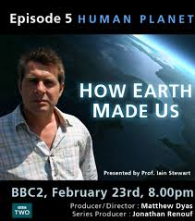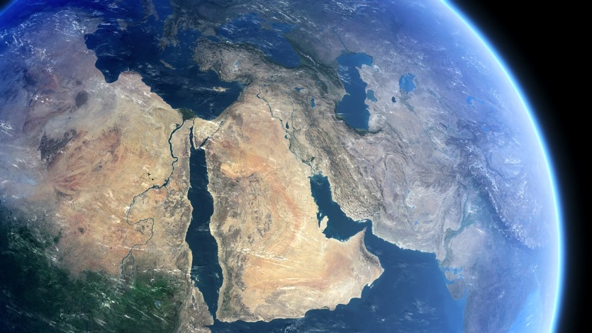

2. 非洲大貓African Cats
長度：89分鐘
由非洲大草原上史詩般的故事改編而成，主人公之一Mara是一隻討喜的小獅子，從小在勤勞及聰慧的母獅群中長大。Fang則是隻勇敢的領袖，保護著牠的家人免受敵獅侵擾。另一隻大貓Sita是一隻勇敢的獵豹，和五位兄弟姐妹一起由母獵豹帶大。在塞繆爾.L.傑克森的解說中，「非洲大貓」捕捉大貓之間的愛、友情及雄心壯志。
An epic true story set against the backdrop of one of the wildest places on Earth, 'African Cats' captures the real-life love, humor and determination of the majestic kings of the savannah. Narrated by Samuel L Jackson, the story features Mara, an endearing lion cub who strives to grow up with her mothers strength, spirit and wisdom; Sita, a fearless cheetah and single mother of five mischievous newborns; and Fang, a proud leader of the pride who must defend his family from a rival lion.
2012年 最佳戲劇獎得主、2012年 Panasonic攝影獎入圍
Winner of 2012 Theatrical Award. Finalist for 2012 Panasonic Cinematography Award.
A production by Disneynature
英國United Kingdom
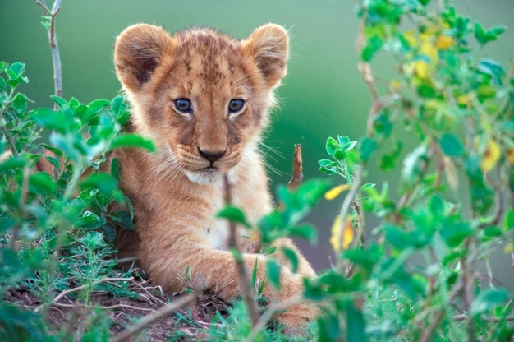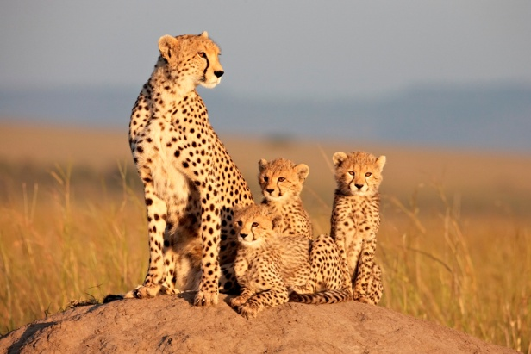

3. 冷杉的旅程The Fir Tree (Grantraeet)
長度：26分鐘
小冷杉的毬果被一隻老鼠綁架了，但她不能留在這裡，必須離開家人到遠方扎根，。小冷杉憧憬未來，充滿野心，她焦急地想要茁壯、成為頂天立地的大樹。在成長的過程中，突破許多困難，但在某年的12月，一個愛上小冷杉的男孩出現，改變了她的世界。
As a cone the little fir tree is kidnapped by a mouse and it must take root and grow up far away from its family. The tree is hopeful and has big ambitions. It wants to grow so high that it reaches the sky and becomes a very successful tree. Through the tree we see the world passing by. It is impatient and only looks forward to growing up as fast as possible. The tree tries to resist all troubles but one day in December everything changes when a little boy falls in love with the fir tree.
2012年Disneynature 創新獎入圍
Finalist for 2012 Disneynature Innovation Award
A production by Plus Pictures
丹麥Denmark
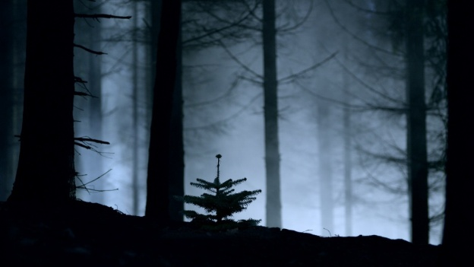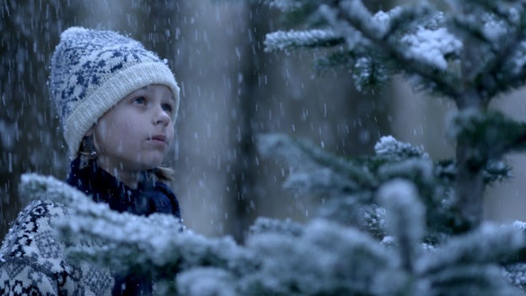

4. 野性匈牙利Wild Hungary
長度：52分鐘
不同於歐洲其他國家，匈牙利的自然生態與河流緊密相連。白尾海鵰、水獺、大鯰魚等許多野生動物與當地居民分享牠們所棲息的濕地。除了白尾海鵰的故事，本片是少數以中歐野生動物生態為主軸的紀錄片，影片呈現許多過去少見的動物行為，例如跳舞的鹿、設法過冬的鯰魚或大遷徙的赤梢魚等。
A country like no other in Europe, Hungary is influenced by the rhythms of its rivers. Whitetailed eagles, otters and enormous catfish share the wetlands with many other species living close to the local people in this densely populated country. Besides the story of a white tailed eagle family Wild Hungary is the intimate portrait of the elusive central European wildlife featuring some never before filmed animal behaviours like dancing deer, wintering catfish or the spectacular run of the asp fish.
2012年 59音效獎入圍
Finalist for 2012 Films at 59 Sound Award
A production by Azara Film and NDR Naturfilm/Doclights for NDR, BR, ARTE in cooperation with ZDF Enterprises
匈牙利Hungary
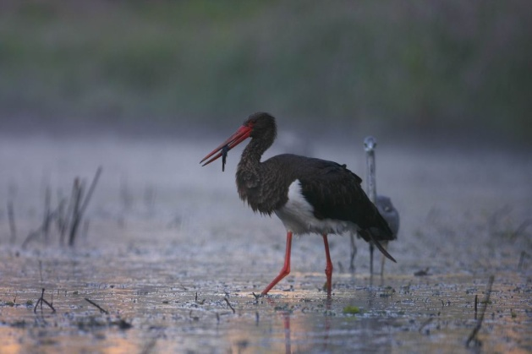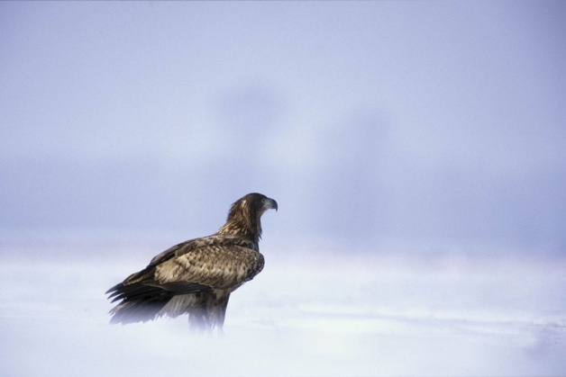

5. 最後之獅The Last Lions
長度：88分鐘
在波札那共和國的奧卡萬戈三角洲中，一隻被家族放逐的母獅以及她的三隻小獅子必須靠自己的力量求生。在經過大火肆虐、其他母獅的刁難以及敵獅追捕等重重考驗後，牠們決定逃往杜巴島，迎向未知的未來。
In Botswana’s Okavango Delta, an ostracized lioness and her three cubs must fight alone to survive. Overcoming all manner of hazards, from the raging wildfires on the Delta and the jealousy of sister lionesses, to the marauding males who kill her mate, and the prey that becomes predator. Their only defence is to escape to Duba Island and an unknown future.
2012年 最佳配樂獎得主、2012年Panasonic攝影獎入圍、2012年 最佳劇院獎入圍
Winner of 2012 Music Award. Finalist for 2012 Panasonic Cinematography Award and 2012 Theatrical Award.
A production by National Geographic in co-production with Wildlife Films & National Geographic Entertainment
波札那Botswana
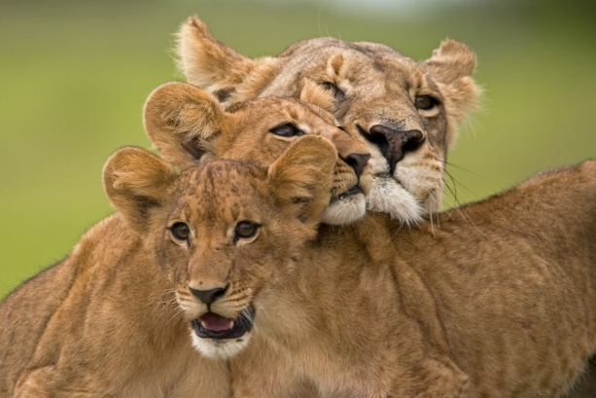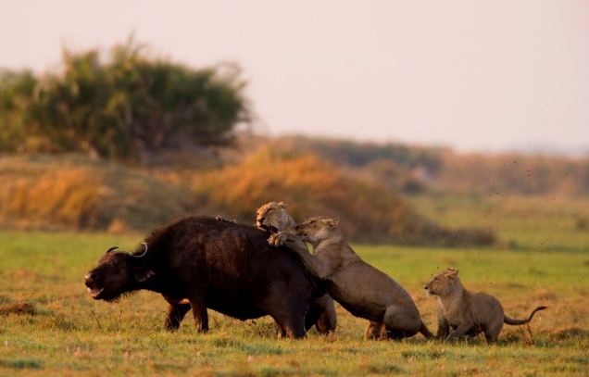

6. 野性斯堪地納維亞：芬蘭 Wild Scandinavia: Finland
長度：52分鐘
芬蘭像是由湖泊及森林組成的馬賽克拼圖，在與俄羅斯的邊界，許多少見的野生動物棲息於此，熊和狼在這片沼澤地遊蕩，西伯利亞飛鼠佔據啄木鳥在樹幹上留下的巢穴。這是從未出現在其他紀錄片中的題材，奧利佛(Oliver Goetzl)及伊佛(Ivo Nörenberg )用高畫質HD呈現野性芬蘭，讓觀眾有機會看見白頰雛鴨跳出洞穴或是兩人與熊及狼巧遇的瞬間。
Finland looks like a mosaic of water and woodland. Close to the Russian border, Finland is home to rare animals, bears and wolves that roam the swampland and the Siberian flying squirrel lives in old woodpecker nest holes. This film shows animal behaviour that has never been filmed before: Oliver Goetzl and Ivo Nörenberg got first shots of a lynx in the Finnish wilderness, brilliant HD highspeed shots of goldeneye chicks jumping out of their tree nest and they also filmed exciting encounters of bears, wolves and much more.
2012年Panasonic攝影獎入圍、2012年 最佳系列影集獎入圍
Finalist for 2012 Panasonic Cinematography Award and Series Award
A production by GULO FILM PRODUCTIONS and NDR Naturfilm / Doclights in co-production with NDR, ARTE, WDR, Terra Mater, National Geographic International, Animal Planet, S4C, SVT & Parthenon Entertainment
德國Germany
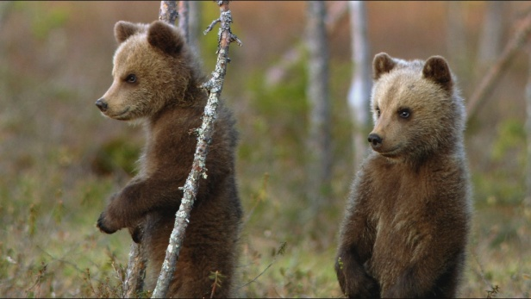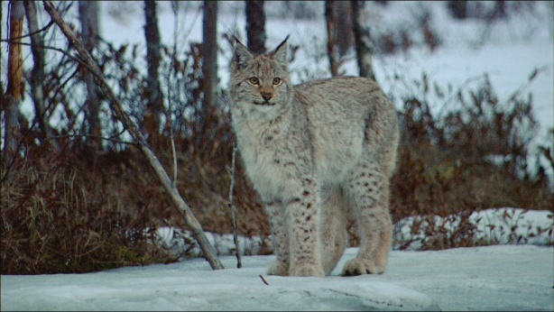

7. 虎之王朝Tiger Dynasty
長度：58分鐘
年輕的雌虎Baghani，以及熱血的雄虎Rajore被選為下一個王朝的開創者，牠們被帶離家鄉，前往另一個野生動物保育區(Sariska國家公園)。牠們的首要之急是適應新生活環境，並學會保護自己，因為這個園區之前住著24隻老虎全數死於盜獵。影片記錄了牠們在園區的前兩年生活，究竟牠們有沒有成功在Sariska國家公園重建老虎王朝？「虎之王朝」將帶觀眾看見不一樣的老虎生態！
A young tigress is chosen to found a new dynasty. Airlifted from her home in Ranthambore National Park to live in a new reserve, Baghani the tigress must learn to adapt to her new territory in Sariska National Park where all 24 tigers were wiped out by poachers. Also released is Rajore, a hot blooded young male. For two years every aspect of their lives are followed by the camera. Will she and her mate survive and reclaim Sariska for tigers? Tiger Dynasty captures some never before captured moments in the lives of tigers.
2012年 獎勵發展中國家影業人員獎入圍
Finalist for 2012 Award to promote filmmakers from developing countries
A production by Grey Films India Pvt Ltd commissioned by BBC Natural World & Animal Planet
印度India
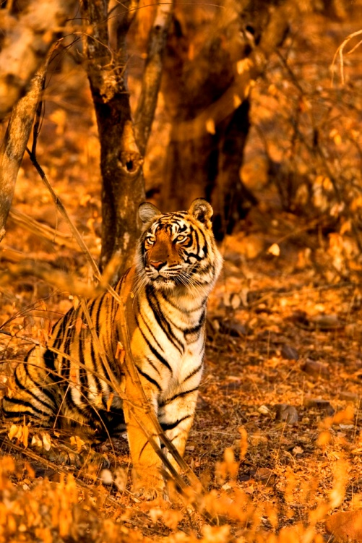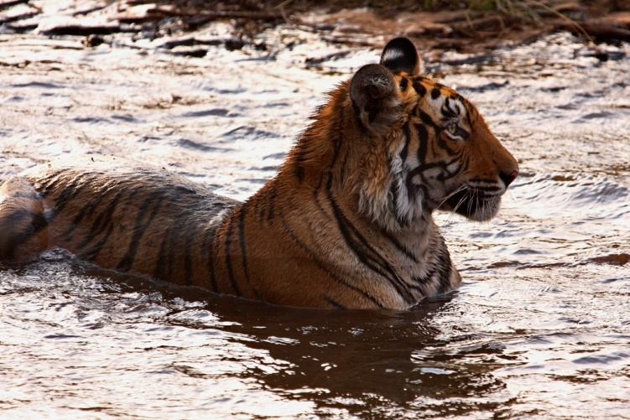

8. 沙漠之蟻帝國Empire of the Desert Ants
長度：59分鐘
在美國亞利桑那的沙漠裡，一隻蜜蟻的蟻后發動一場殘酷爭鬥，以建立並保護牠的王國。不論是犧牲同族或自相殘殺，牠使出渾身解數只為消除異己，保住自己的后位。「沙漠之蟻帝國」描述蜜蟻后如何建立自己的王朝，以及從后位上殞落的故事。
Natural World visits the Arizona desert, where a new honey ant queen wages an intense battle for survival as she attempts to build and defend her empire. Eliminating rivals with ruthless efficiency, sacrificing thousands in her quest for domination, murder, cannibalism, genocide - she will do anything to keep her crown. Empire of the Ants is the epic story of one honey ant queen’s dramatic rise to power - and her brutal fall from grace.
2012年 最佳動物行為獎入圍
Finalist for 2012 Animal Behaviour Award
A BBC & Animal Planet co-production
英國United Kingdom
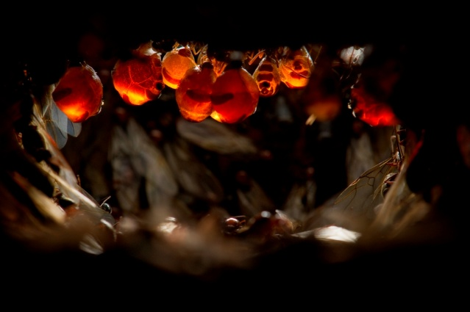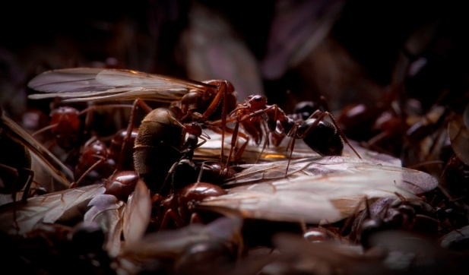

9. 綠之宇宙The Green Universe (Unser Wald - Das Grune Wunder)
長度：93分鐘
森林深處是個神奇又迷幻的地方，但同時也是弱肉強食的競爭之地。這部影片是為大螢幕量身訂做，讓觀眾能夠盡情欣賞中歐森林之美及生物多樣性。人們所熟悉的動植物以及少見的標本都將出現在影片中，拼湊出令人驚奇的生態，也顯露積極保育的重要性。
Deep in the forest are magical and enchanted spots... But this is also where the fight for life is fought out, and only the strongest win. This film was designed for the big screen, showing the most beautiful and most diverse habitat of Central Europe - The Forest. Stories of well known species, as well as portraits of unknown specimens are told. In the end, everything fits together like a puzzle and a new and radical thesis of nature conservancy is revealed.
2012年 最佳剪輯獎得主
Winner of 2012 Editing Award
A production by nautilusfilm GmbH and NDR Naturfilm / Doclights in co-production with NDR, Polyband Medien GmbH
德國Germany
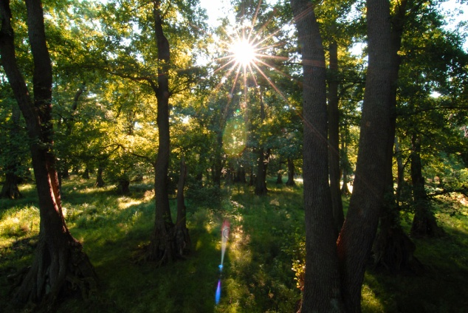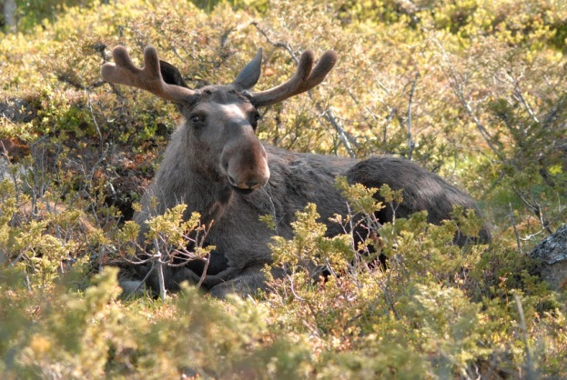

10. 河馬：自然的野地盛宴Hippo: Nature's Wild Feast
長度：80分鐘
本片使用高科技呈現自然史，詮釋自然界食物鏈的關係。尚比亞的盧安瓜峽谷中住著非洲最具代表性的動物，獅子、豹、鱷魚和禿鷹都爭相搶食河馬的屍體，這份含有兩百萬卡路里的大餐，將能提供牠們多日的養分。一組遠端操控的攝影機日夜紀錄逐漸減少的河馬殘骸，來自各國的科學家們也投入研究一隻巨大河馬的死亡如何餵養了其他無數物種。
Hippo: Nature’s Wild Feast' is a high-tech natural history event that presents the most comprehensive illustration to date of nature’s food chain in action. Filmed in Zambia’s Luangwa Valley, we reveal Africa’s most iconic animals - including lions, leopards, crocodiles, hyenas and vultures as they fight for access to the two million calories stored in a hippo carcass. A network of remote-control cameras captures the action night and day as the hippo is reduced to scraps, while an international team of scientists analyse how the death of one of Africa’s most iconic animals sustains life for countless other species.
2012年Disneynature創新獎得主、2012年 最佳主持人入圍、2012年西英格蘭大學大眾播映獎入圍
Winner of 2012 Disneynature Innovation Award. Finalist for 2012 Presenter-led Award and UWE Popular Broadcast Award
A production by Tigress Productions
英國United Kingdom
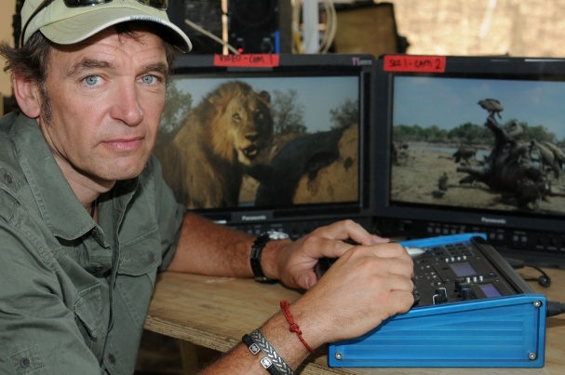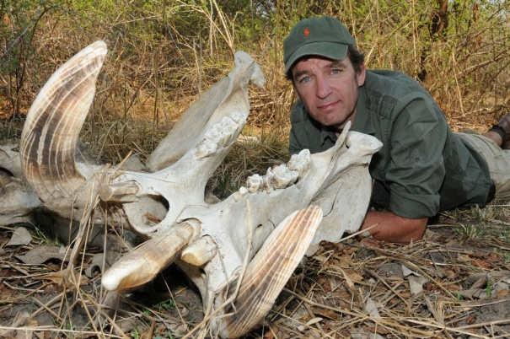

11. 冰凍星球：直到世界盡頭Frozen Planet - To the Ends of the Earth
長度：58分鐘
在經過六個月的永夜後，太陽重新高掛北極天空。影片先隨著大衛深入北極，看見兩隻北極熊展現牠們柔情的一面、雄偉的瀑布投身為格陵蘭冰蓋的一部分、巨大的冰山崩塌入海，以及25隻巨狼對抗強大的野牛等。跨越地球上最大的冰蓋，旅程來到南極，虎鯨群隨海浪沖上冰層捕食海豹，影片則帶觀眾深入水底，探索史前時代遺留的巨大水晶洞穴和海底火山。
Our journey begins with David at the North Pole, as the sun returns after six months of darkness. Two polar bears show their tender side, giant waterfalls plunge into the Greenland ice-sheet and colossal icebergs calve into the sea. 25 giant wolves take on formidable bison. In Antarctica, orcas make killer waves to wash seals from ice. We enter an underwater realm of prehistoric giants, and explore extraordinary crystal caverns in a live volcano. We cross the largest expanse of ice on earth, the Antarctic ice-cap, to rejoin David at the South Pole 100 years after humans first stood there.
2012年 最佳音效獎得主、2012年 最佳系列影集獎得主、2012年 最佳配樂獎提名
Winner of 2012 Films at 59 Sound Award and 2012 Series Award.
Finalist for 2012 Music Award.
A BBC, Discovery Channel, Antena 3 Television S.A., ZDF, Skai, Open University Co-Production in association with Discovery Canada
英國United Kingdom
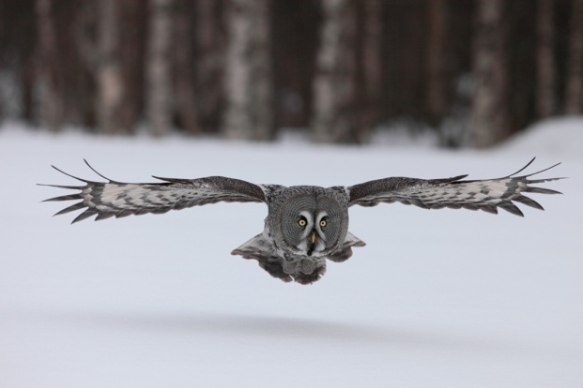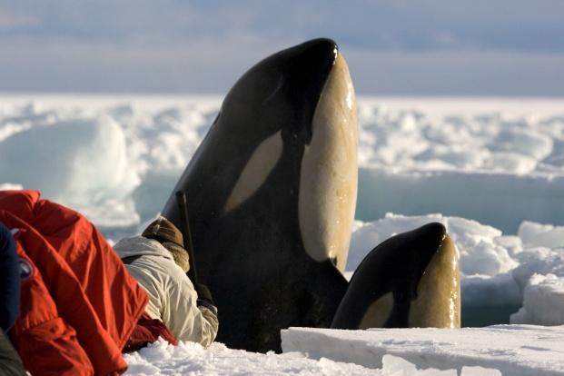

12. 疏林草原皇后Queen of the Savannah
長度：58分鐘
什麼動物讓非洲大象聞之喪膽？答案竟是草原皇后——蜜蜂。這部影片重現女王蜂的生活以及牠的族群。影片利用突破性的近距離拍攝技術，以蜜蜂的視角看牠們的世界。女王蜂為爭奪后位不惜殺害姊妹，但牠也成功帶領蜂群壯大、抵抗外侮及遷徙橫跨肯亞尼山。
The queen African honeybee rules the savannah - even elephants panic at the buzzing of her nest. This film recreates the life of one queen bee and her colony as they fight to survive. Ground-breaking close-up photography shows a bee-eye view of their world, from the queen murdering her sisters to fighting off giant invaders and eventually migrating across the savannah to the great Mount Kenya.
2012年 最佳劇本獎入圍
Finalist for 2012 Script Award
A production by BBC co-produced with Animal Planet
英國United Kingdom
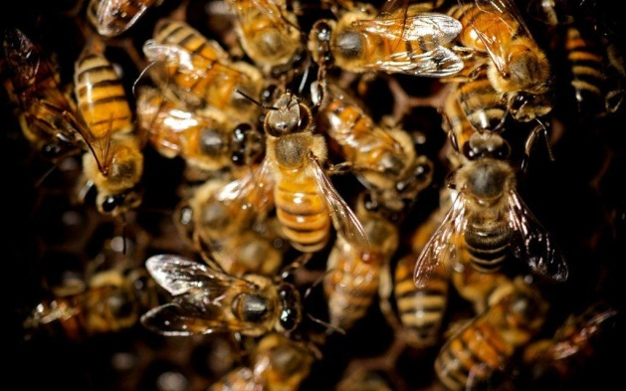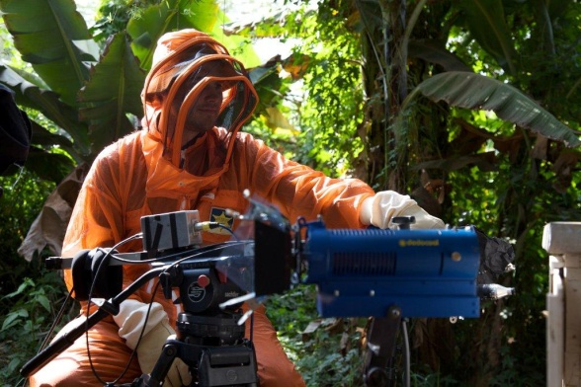

13. 蜂鳥—寶石信差Hummingbirds - Jewelled Messengers
長度：53分鐘
這部影片將告訴你蜂鳥如何展現地球上最靈敏的飛行技術，牠們能在空中徘徊停留、向後飛行並能在空中翻跟斗。這部紀錄片將帶觀眾瞭解生物界如何創造蜂鳥，使牠們能夠擔任花朵之間的信使，傳授花粉。牠們是地球上最小的溫血動物之一，這些精靈般的小鳥將告訴觀眾生命的無限可能。
This is the story of how hummingbirds became the greatest aerial acrobats on earth. Plants created hummingbirds as their messengers, carrying pollen from flower to flower. The film follows the evolution of the birds, as they are shaped by their role as go-betweens. Hummingbirds have the highest metabolism of any vertebrate and they can hover, fly backwards and upside down. They have the smallest warm-blooded creature on earth in their number. These glittering birds live on the edge of what is possible.
2012年 評審團特別獎得主
Winner of 2012 Jury's Special Prize
A Terra Mater Factual Studios & Free Spirit Films production
奧地利Austria
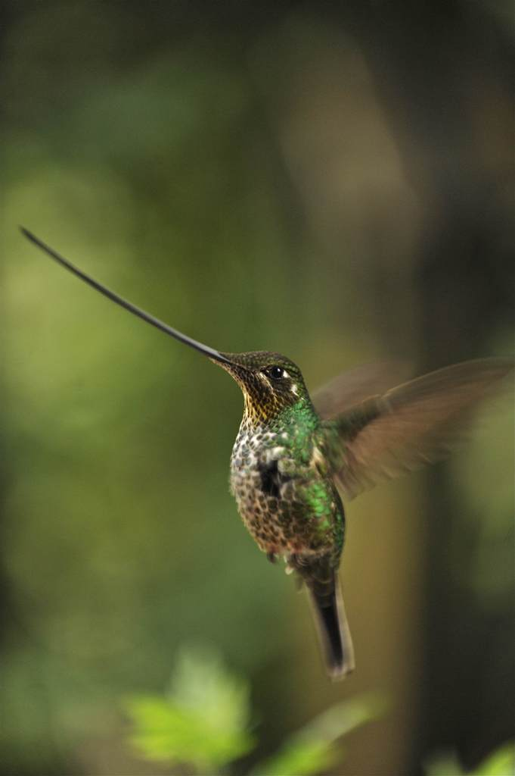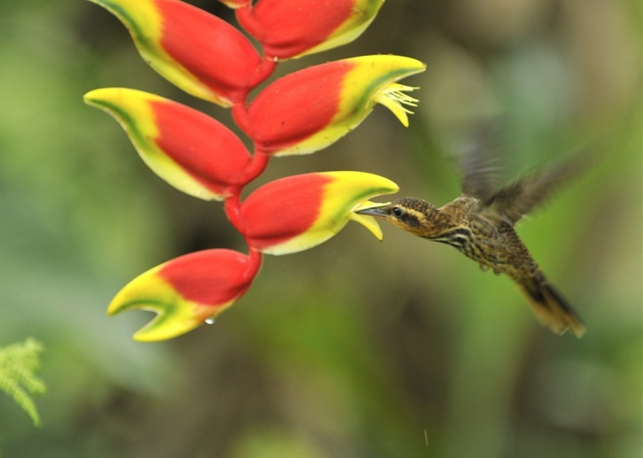

14. 恆河—生命的緞帶Ganga - Ribbon of Life
長度：45分鐘
印度恆河並不是世上最長或最雄偉的河流，但從它發源到入海的兩千五百公里流域中，它灌溉了實質的土地和無形的人心。然而，由於快速的工業化及人口膨脹，恆河正面臨著嚴重的乾枯及汙染威脅。乾枯死去的恆河是人們不敢想像的未來。這部影片試圖在技術及文化兩方面找出威脅恆河的原因，可能造成的影響，以及可行的解決方式。
The Ganges is neither the longest river on Earth nor the most awe-inspiring, but through its 2,500 km journey from its source to the sea, it flows through the physical and spiritual heart of India. However, due to rapid industrialisation and an exploding population the Ganges today is facing increased pressure from water extraction and pollution. The unthinkable, a dry dead Ganges, is a distinct possibility within our lifetime. This film explores causes, effects and possible solutions for the problem of pollution both cultural and industrial - on the Ganges.
2012年獎勵發展中國家影業人員獎得主
Winner of 2012 Award to promote filmmakers from developing countries
A Cinema Vision India production commissioned by Ministry of Environment & Forest, Govt. of India
印度India
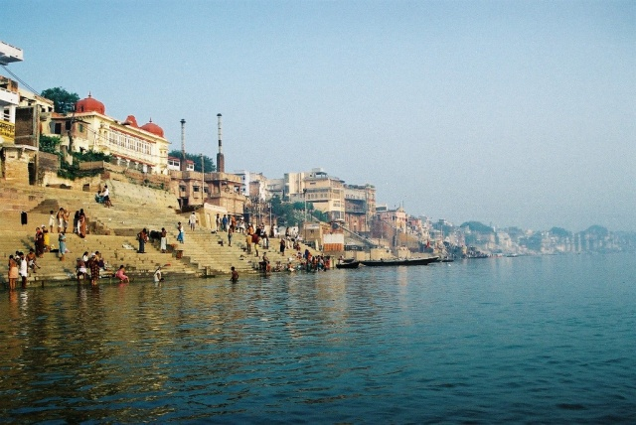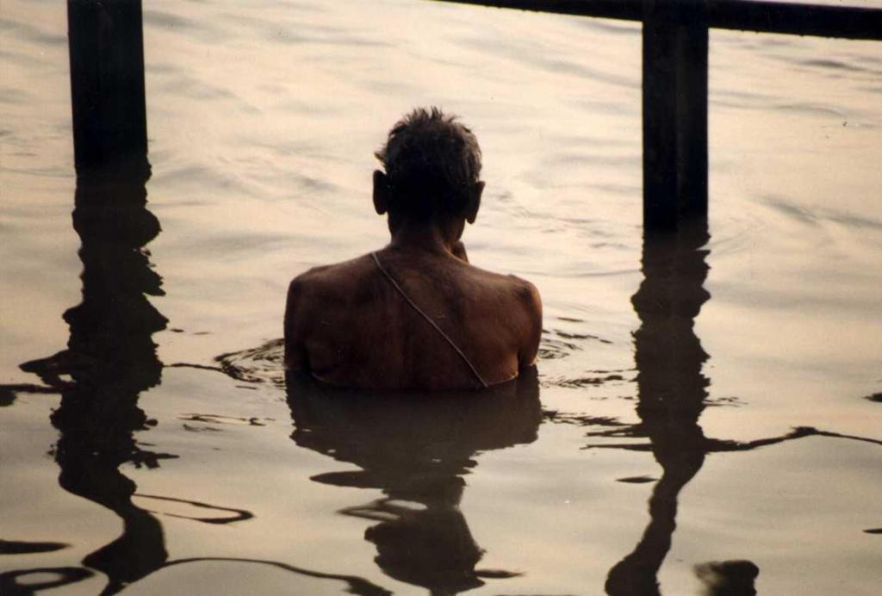

15. 超級聰敏動物：第1集Super Smart Animals: Episode 1
長度：60分鐘
過去人們始終認定人類的智慧讓所有其他物種望塵莫及，動物們不可能會交談、解決問題也沒有感情。然而，這部影片將告訴你事實絕非如此，其實，動物們比我們想像的聰明許多。牠們擁有我們曾認為是人類專屬的能力：懂得使用工具、能思考、有自己的語言及文化、甚至有反省的能力。莉絲(Liz Bonnin) 將在影片中告訴你，這些超級聰敏動物遠比你想像的還有聰明！
For centuries, the idea of intelligent animals struck most people as ridiculous. The concept that they could talk, solve problems, even feel emotion was the stuff of fiction. But not any more: the latest science reveals that animals are a lot smarter than we thought. Tool use, insight, language, culture, emotion, consciousness are all qualities we once thought uniquely human. But over the course of two programmes, presenter Liz Bonnin gradually discovers that Super Smart Animals have them all.
2012年 兒童首選獎得主
Winner of 2012 Children’s Choice Award
A BBC & Discovery Channel co-production
英國United Kingdom
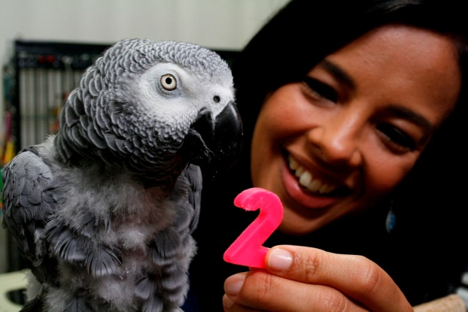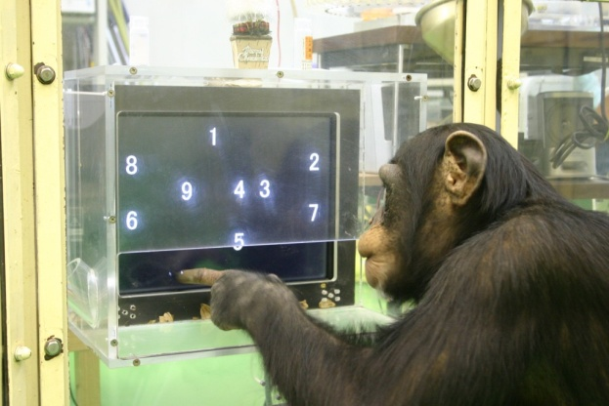

16. 人類星球：叢林—樹之人Human Planet: Jungles - People of the Trees
長度：60分鐘
叢林生活揭露了人類依賴自然環境生存的智慧與能力。在委內瑞拉，勇敢的小孩能捕獲比臉還大的蜘蛛。在巴布亞幾內亞，Kuruai族人會將家畜或小孩放在樹屋中確保他們的安全。在西非，Ba’aka族人用和諧的歌聲和水鼓在糾結的雨林中溝通；採蜜者靠著簡單的藤蔓和平衡感爬上40公尺高的樹梢，從憤怒的蜜蜂群中取走蜂蜜。透過空拍畫面，觀眾將能看到這些未曾與外界接觸過的亞馬遜原始部落生活。然而，我們該如何對待這樣與世隔絕的部落？是該任其發展，或是需由外力介入，以保護他們免受侵擾呢？
Human Planet - Jungles' reveals the ingenuity and resilience that humans use to survive in the Jungles of the world. With stunning photography we witness the courage of Venezuelan kids as they hunt goliath tarantulas. In Papua a Kuruai family build a treetop house complete with toddlers and pigs. In West Africa, Ba’aka use harmonic singing and water drumming to communicate through the tangled rainforest, and a honey collector climbs over 40m using simple vines and balances across open branches to collect his prize from angry bees. In a powerful aerial story Jungles reveals never-before-seen footage of a previously uncontacted tribe deep in the Amazon, posing the question: are such communities best left alone or do they need protecting from the outside world?
2012年 最佳系列影集獎得主
Winner of 2012 Series Award
A BBC & Discovery Channel co-production
英國United Kingdom
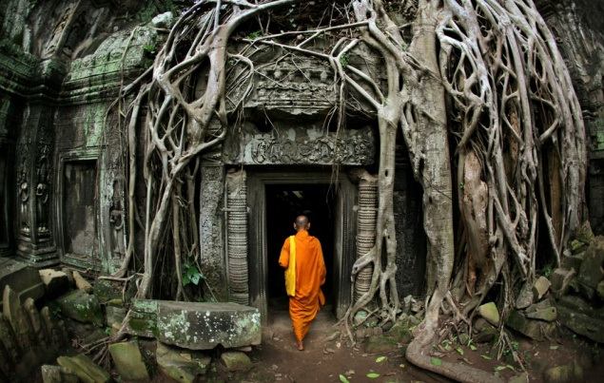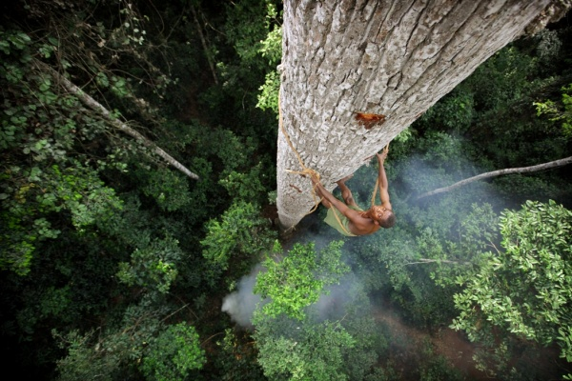

17. The Forest: The Fight for Light
長度：44分鐘
中歐的森林是一片隱密世界，森林居民享受著自己的祕密生活。無數的生物，不論大小，都居住在同一片土地上，他們如何相安無事的生活在一起？可想過這樣的世界是遵循自然的演化，或是人類活動的結果呢？
The Central European Forest, a secret place whose inhabitants live clandestine lives. How do innumerable organisms, large and small, live together? Are our forests truly natural or the result of man's intervention? Do they have anything in common with untouched wilderness?
2010年 最佳配樂獎入圍
Finalist for 2010 Music Award
A nautilusfilm production, commissioned by NDR Naturfilm, ARTE & ORF
德國Germany
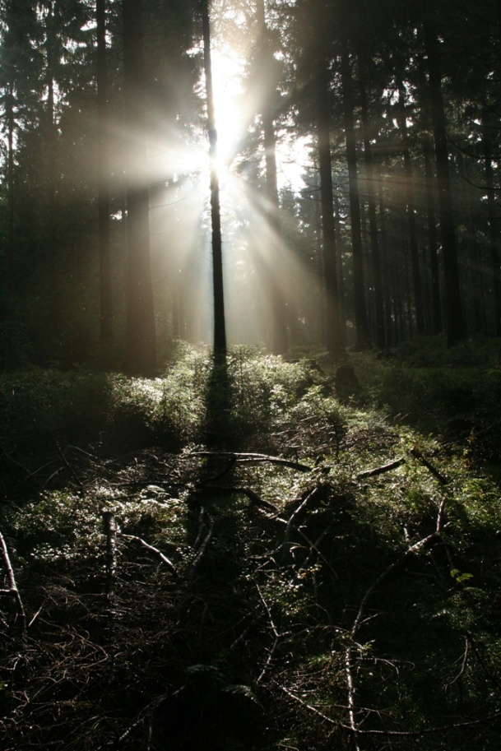

18. 解剖巨物：長頸鹿Inside Nature's Giants - The Giraffe
長度：49分鐘
解剖巨物揭露大型動物體內獨特且不為人知的生理運作。為什麼長頸鹿演化出這麼長的脖子？對李察(Richard Dawkins)而言，解剖長頸鹿將能為他提供相當重要的研究資料。在長頸鹿脖子中交錯的複雜神經系統連結聲帶、大腦及其他器官，影響長頸鹿的智力發展，也幫助牠們在演化潮流中脫穎而出。
‘Inside Nature’s Giants’ delves under the skin of the world’s largest animals to reveal their unique anatomy and unravel their evolutionary secrets. Creationists hold up the giraffe as the ultimate challenge to evolution - how could a creature have evolved such a long neck? But for Richard Dawkins the internal anatomy of the world’s tallest animal provides some of the best arguments in favour of natural selection. Some nerves take huge detours up and down the long neck – from the voice box to the brain – hardly the work of an Intelligent Designer.
2010年 最佳系列影集獎入圍
Finalist for 2010 Series Award
A Windfall Films production, commissioned by Channel 4 Television & National Geographic Channel
英國United Kingdom
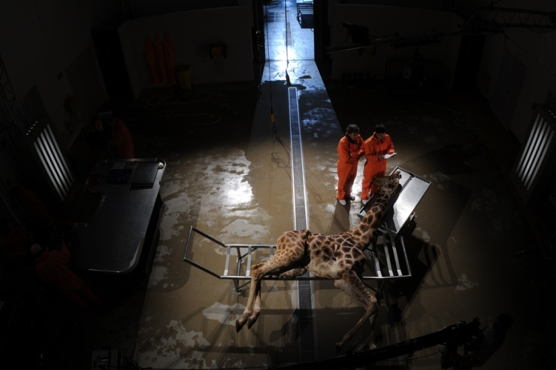

19. 南太平洋：易碎的天堂South Pacific: Fragile Paradise
長度：60分鐘
相較於地球上許多地方，今日的南太平洋依然是乾淨、健康且充滿生命力的海洋天堂。然而，跨國漁業船隊正大肆掠奪這片海洋，加上海平面上升、海洋汙染等問題，美麗的南太平洋正面臨前所未有的威脅。這部紀錄片探討現行的南太平洋保育策略，並誠實地呈現捕魚方式，及其對海洋所帶來的威脅。
The South Pacific is still relatively healthy and teeming with fish, but it is a fragile paradise. International fishing fleets are taking a serious toll on the largely unique varieties of fish and wildlife. There are also many other issues such as rising sea levels and pollution posing as a threat to these bountiful seas. This film looks at the conservation measures being taken in order to preserve the ocean and its wildlife and highlights in a very honest and visually arresting way the issues faced by the South Pacific, one of the few healthy seas left.
2010年 評審團特選放映
Judges' Special Selection for Screening 2010
A BBC and Discovery Channel (USA) co-production
英國United Kingdom
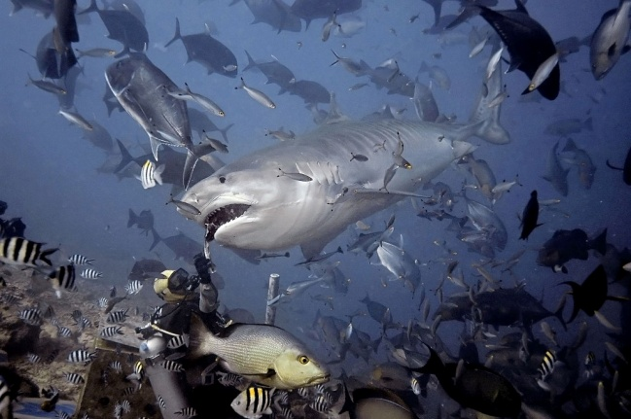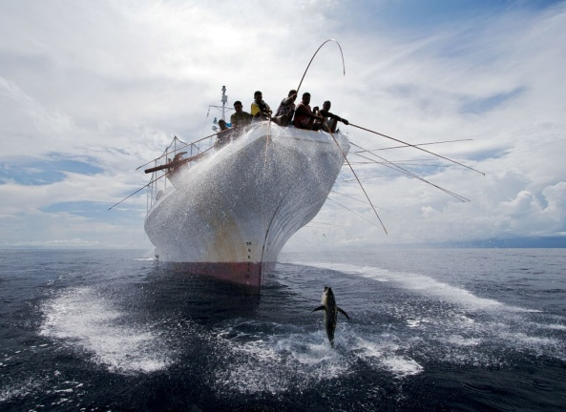

20. 失落的火山：第3集Lost Land of the Volcano: Episode 3
長度：60分鐘
「失落的火山」系列結合科學家及攝影團隊，深入地球上少數未受破壞的叢林，拍攝令人屏息的野生動物，以及充滿活力的雨林世界。在紐幾內亞一個崎嶇的熱帶島嶼上，許多奇特的物種以此為家。島上的博薩維山是被雨林覆蓋的火山，研究及攝影團隊選擇在此山腳下紮營，並在當地居民的帶領下深入雨林，尋找棲息於此的動物。更重要的是，他們必須找到足以勸說世人保育這片雨林的證據。
Lost Land of the Volcano' combines stunning wildlife with high octane adventure as a team of scientists and wildlife filmmakers explore one of the last great unspoilt jungle wildernesses on earth. New Guinea, a rugged tropical island that is home to some of the strangest creatures on the planet. The team is based at the foot of Mount Bosavi, a giant extinct volcano covered in thick and largely unexplored rainforest. With the help of trackers from a remote tribe they aim to search for the animals that live there and find evidence that may help preserve this last great jungle forever.
2010年 最佳系列影集獎入圍
Finalist for 2010 Series Award
A BBC production
英國United Kingdom
